INSTRUCTION MANUAL FOR ORBITAL SHAKER OS-D SERIES

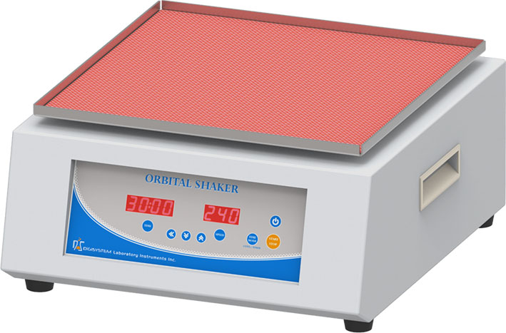
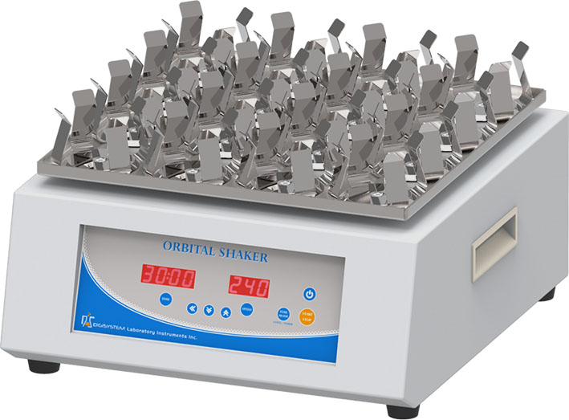
Platform
Clamp

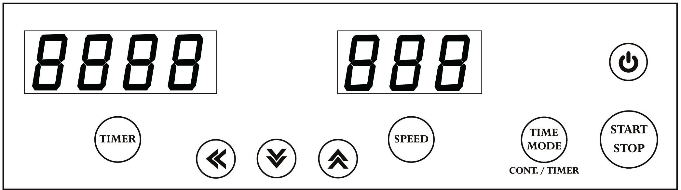
SPEED display
TIME display
Control panel

Warnings:
* Do not remove the machine during operation.
* Do not disassemble the rotator by yourself. In the event of a malfunction, the rotator should be repaired by a qualified technician. Before repairing, turn off the power.
Steps:
- Place the orbital shaker on a flat and stable bench top or ground. Plug the digital rotator into a properly grounded outlet which corresponds with the electrical requirements on the label back on machine.

- Place and fix the specimen on the Platform or clamps. Press key to be power on. First, the SPEED and TIME display will show the speed and time value that you set last time. If the previous timed mode setting is Cont. mode (Continuous mode), you will see ‘cont’ on TIME display.

- Setting time: Press the key to select the time mode (Timed mode or Continuous mode).
  - If the continuous mode is selected, the TIME display will show ‘cont’.
  - If the timer mode is selected, the previous setting value will show on the TIME display.

    - Press key, and the digits on the TIME display is flashing. (Time display is Hour: Minute; for the last one minute, it will display the remaining seconds)

    - Press key to select the digit.


    - Press key or key to adjust the value.
    - Press key or any other keys to save the time value.
- Setting speed:

  - Press key, and the digits on the SPEED display is flashing.
  - Press key to select the digit.
  - Press key or key to adjust the value.
  - Press key or any other keys to save the speed value.

- Press key to start the machine. During the operation, you can press key to stop the machine anytime.
Maintenance and care:
Keep the machine clean all the time, so no routine maintenance is required. Cleaning can be done with a damp cloth. Avoid the use of solvents as they may damage the machine housing.
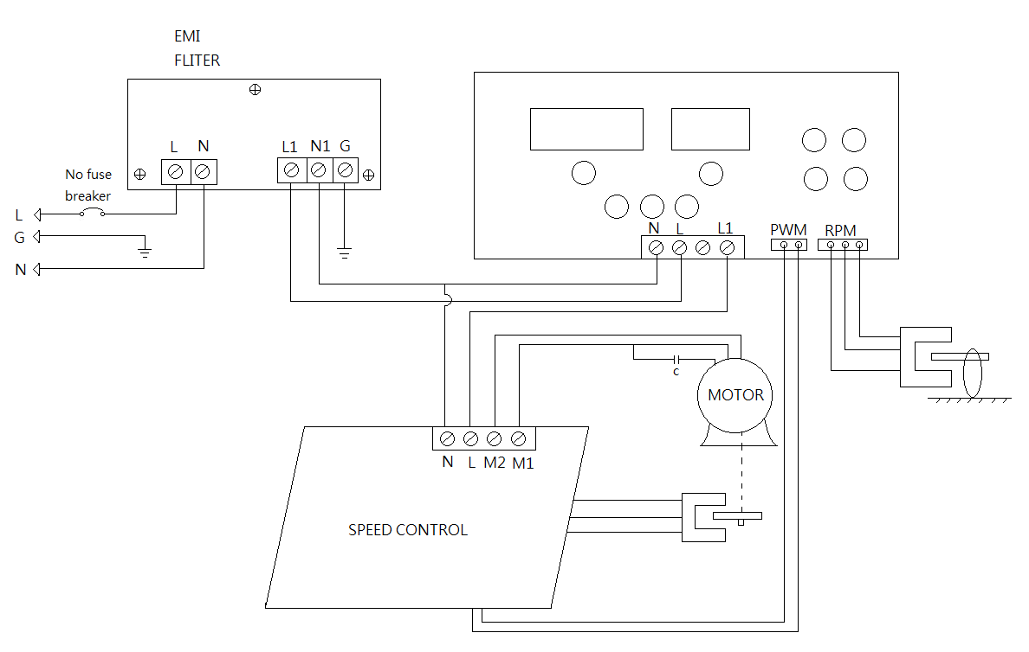
Circuit Diagram:

Troubleshooting Guide
Caution: Always disconnect the power cord before troubleshooting.
Trouble | Cause | Remedy
Instrument inoperative | Power cord not connected to outlet. | Plug in the power cord.
Instrument inoperative | Dead power output. | Change to different output.
Instrument inoperative | Fuse blown. | Change a new fuse.
Instrument inoperative | Defective electronic component. | Contact your distributor for repair.
Error message: run | Before the motor stops completely, press Power key to be power on. | Re-star the centrifuge, after the motor stops completely.
Platform doesn’t rotate | Power is not on. | Press POWER key.
Platform doesn’t rotate | Start/Stop key is not pressed. | Press the Start/Stop key.
Platform doesn’t rotate  (Error message: Er-P) | Belt is broken or worn-out. | Contact your distributor for repair.
Platform doesn’t rotate  (Error message: Er-P) | PC board is broken. | Contact your distributor for repair.
Platform doesn’t rotate  (Error message: Er-P) | Motor is broken. | Contact your distributor for repair.
Platform keep rotating when time is up | PC board is broken. | Contact your distributor for repair.
Speed is abnormal | PC board is broken. | Contact your distributor for repair.
No signal on LED DISPLAY | PC board is broken. | Contact your distributor for repair.

